SMDM PROJECT
Submitted By- Deepti Agrawal

PROBLEM 1: WHOLESALE CUSTOMER ANALYSIS (Wholesale+Customers+Data.csv)
A wholesale distributor operating in different regions of Portugal has information on annual spending of several items in their stores across different regions and channels. The data consists of 440 large retailers’ annual spending on 6 different varieties of products in 3 different regions (Lisbon, Oporto, Other) and across different sales channel (Hotel, Retail).
Please refer to the Jupyter File for the code working.
Exploratory Data Analysis (EDA):
We do the EDA of the data to discover patterns, summarize data and to observe the graphical representations.
Firstly, we will check on how the data looks like by showing the first five rows.
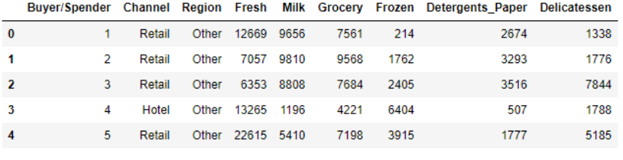
From this, we observe that the dataset has 9 variables: Buyer/Spender, Channel, Region, Fresh, Milk, Grocery, Frozen, Detergents_Paper and Delicatessen.
Channel and Region both are categorical columns while Buyer/Spender, Fresh, Milk, Grocery, Frozen, Detergents_Paper and Delicatessen are all of integer type.
The data shows annual spending on 6 items in a particular distributor’s stores in different regions and channels in Portugal.

Descriptive Statistic for the Dataset:
Now, we will try to understand the features of this data through short summaries regarding the measures and statistics.
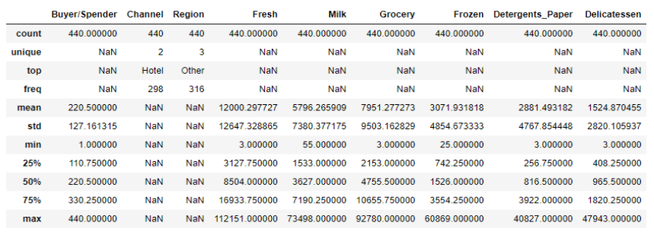

We can observe that, there are 3 unique regions with Other regions having the highest number of values in the column.
Also, there are 2 unique channels with Hotel Channel having the most values in the column.
The minimum spending on fresh items is 3 whereas for Milk, minimum spending is 55.

Checking for Null Values in the dataset
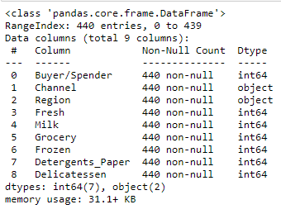
From the above results, it is evident that there are no null values in the dataset.
Also, the dataset has 440 instances and 9 attributes.

Q 1.1 Use methods of descriptive statistics to summarize data. Which Region and which Channel seems to spend more? Which Region and which Channel seems to spend less?

Using describe () to summarize the data

The five numbers that help describe the center, spread and shape of the data are:
- XSmallest- shown by min
- First Quartile (Q1)-shown by 25%
- Median (Q2)-shown by 50%
- Third Quartile (Q3)-shown by 75%
- XLargest-shown by max

The data can be summarized by the above mentioned table which shows the basic point information of the data i.e mean, standard deviation, minimum, maximum, IQR, etc.
We can observe that, there are 3 unique regions with Other regions having the highest number of values in the column.
Also, there are 2 unique channels with Hotel Channel having the most values in the column.
The minimum spending on fresh items is 3 whereas for Milk, minimum spending is 55.

Checking skewness of the data

Now, checking the amount of distortion that every item shows from the symmetrical bell-curve or normal data through checking the skewness quotient.
If skewness is positive, it shows the data is skewed to the right.
If skewness is positive, it shows the data is skewed to the left.

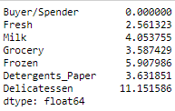

We can see from the above skewness quotient that:
Fresh Milk is least skewed and all the items are skewed to the right (all positive).
Delicatessen has a very high amount of skewness.

Plotting the histograms for all the variables present to observe the pattern of distribution.
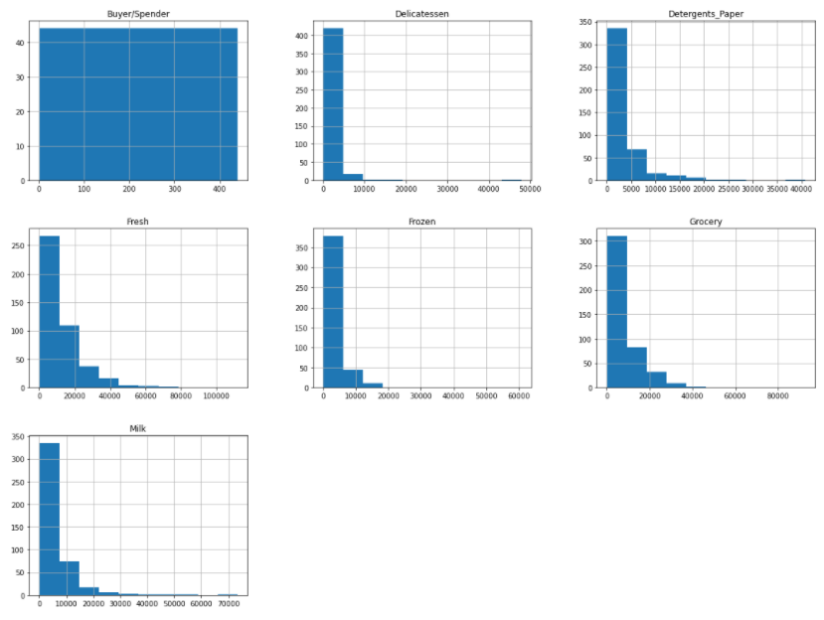
Now, performing our analysis on the Region and Channel
Checking the count of Channel and Region attribute through separate value_counts() function.
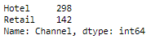
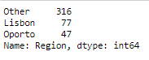
This shows that, annual Spending are more through Hotel Channel and Other region..

Alternatively, plotting a count plot for both Region and Channel
Count Plot of Region and Channel
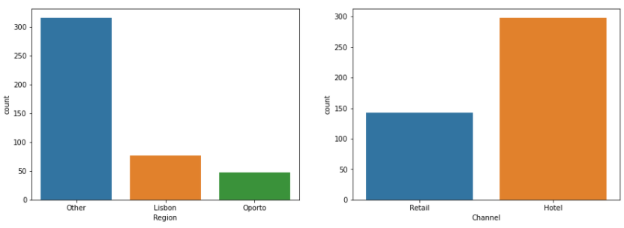
Inference
From the above count plot of Region and Channel, we can infer that:
Hotel Channel and Other Region seem to spend more.
Oporto Region and Retail Channel seem to spend less.

Q 1.2 There are 6 different varieties of items are considered. Do all varieties show similar behaviour across Region and Channel? Provide justification for your answer.

First, we will be checking the skewness quotient for all the attributes to check the amount of distortion that every item shows from the symmetrical bell-curve or normal data.
If skewness is positive, it shows the data is skewed to the right.
If skewness is positive, it shows the data is skewed to the left.

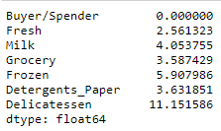
We can see from the above skewness quotient that:
Fresh Milk is least skewed and all the items are skewed to the right (all positive).
Delicatessen has a very high amount of skewness.

Now, we will analyse different varieties of items through plotting a box-plot considering the regions and channels.
The box-plot displays the distribution of data based on the five number summary namely:
• XSmallest- shown by min
• First Quartile (Q1)-shown by 25%
• Median (Q2)-shown by 50%
• Third Quartile (Q3)-shown by 75%
• XLargest-shown by max

We have also added a hue of Region to the box-plot, which helps us observe a relative summary with respect to both channel and region.
x-axis: shows the different channels
y-axis: frequency of the item considered.

Region is displayed through 3 colours:
Blue is for Other region, Orange for Lisbon region and Green for Oporto Region.
Box-Plot of all 6 items with respect to Region and Channel

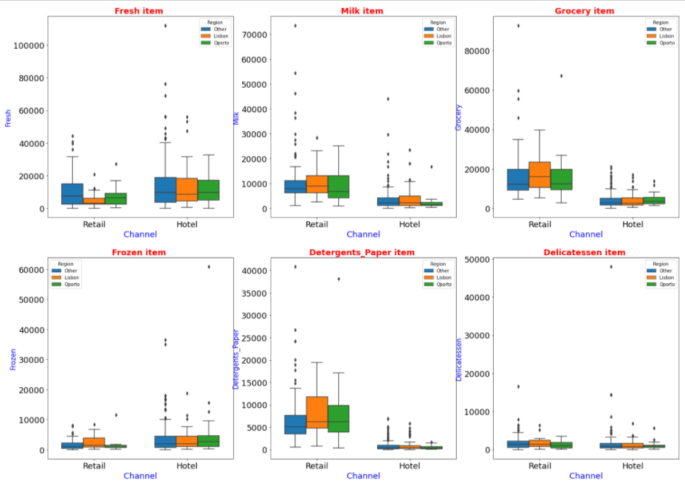
Inference from Box-Plot
We can see that the spending across retail and hotel channel is different for all the items except Delicatessen, where it seems quite similar in all regions and both channels.
Fresh item
- Fresh item shows quite similar distributions in all regions in the hotel channel. But, shows variations in all regions in the retail channel.
- There is much variation in spending across other region in the hotel channel due to more outliers.
- This item has the least spending in Retail channel in Lisbon region due to the compact shape of the box-plot.
Milk item
- There is much variation in spendings across other region in the both hotel and retail channel due to more outliers and therefore a huge spread.
- the spendings in hotel is lesser than that in retail channel as the plot is more compact in the hotel channel
Grocery
- Grocery items has less spendings in the hotel channel in all regions but shows uniform distribution in retail channel in Lisbon region.
- There are high variation in spendings across other region in the retail channel due to more outliers.
Frozen item
- The spendings are highly right skewed as the upper whisker is longer.
- it shows almost similar spendings in different regions in the hotel channel
- spendings on frozen item is very less in the Oporto region
Detergents_Paper item
- Spendings on Detergents_Paper item is very less in all regions in hotel channel.
- There are high variations in spendings across other region in the retail channel due to more outliers.
Delicatessen item
- The spendings on Delicatessen items is least in all regions and channels as compared to all other items.

Inference
Therefore, we can infer that, all varieties of items does not show similar behaviour across different regions and channels.

Q 1.3 On the basis of a descriptive measure of variability, which item shows the most inconsistent behaviour?
Which items show the least inconsistent behaviour?

Plotting histograms for all the items to check their frequency distributions individually.
X-axis: shows the items
Y-axis: shows the frequencies
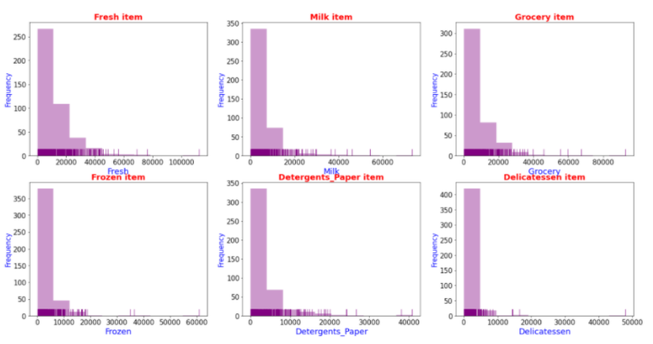
Calculating the Coefficient of Variation (CV)

Coefficient of Variation or Relative Dispersion is defined as the ratio of standard deviation to mean.

CV=Standard deviation/Mean

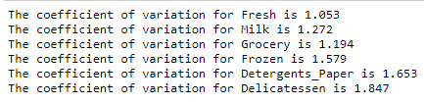
Inference
Delicatessen items shows the most inconsistent behaviour as it shows the highest value of coefficient of variation. i.e. (1.847)
Fresh items show the least inconsistent behaviour as it shows the least value of coefficient of variation. i.e. (1.053)

Q 1.4 Are there any outliers in the data?
We plot a box-plot to check for outliers in the data.
An outlier is a data point that lies at an abnormal distance from the other values in a random sample from a population.
In the below mentioned plot, the dots represents the outliers in the data.

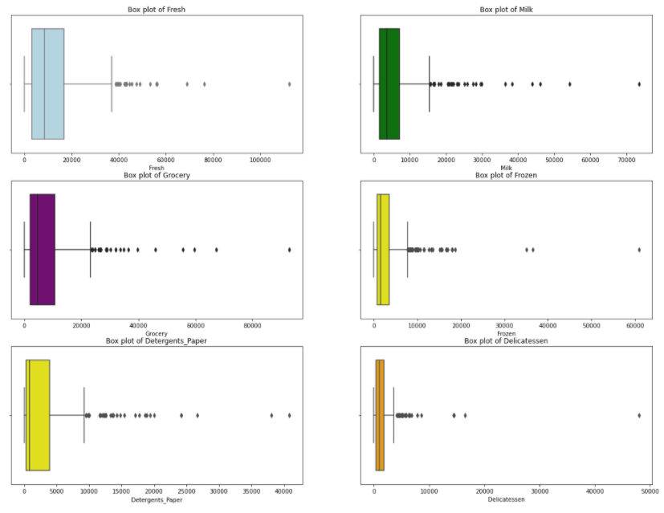
We can see that the data has outliers in all the items i.e. Fresh, Milk, Frozen, Grocery, Detergents_Paper and Delicatessen.
Also, all of them are right skewed as the right whiskers are longer.

Q 1.5 On the basis of your analysis, what are your recommendations for the business? How can your analysis help the business to solve its problem? Answer from the business perspective.

From the given analysis, we can say that annual spending on fresh item is good in both the channels and all regions. Therefore, the distributor should have more of fresh items in the stock.
Also, Delicatessen items should not be over stocked in any store.

Retail channel has a good spending on Fresh, Milk, Grocery and Detergent Paper items therefore, these should be more visible and should have enough stock.
The Hotel channel has good spendings on Fresh and Frozen items only.
There are more retail distribution in the Lisbon Region.

In case of Fresh items, the better distribution channel would be through Hotel channel.
Detergents and Paper items have a huge sale opportunity in Retail Sector and very less in Hotel channel.

PROBLEM 2: (Survey-1.csv)
The Student News Service at Clear Mountain State University (CMSU) has decided to gather data about the undergraduate students that attend CMSU. CMSU creates and distributes a survey of 14 questions and receives responses from 62 undergraduates (stored in the Survey data set).

Please refer to the Jupyter File for the code working.
Exploratory Data Analysis:
Firstly, we will check on how the data looks like by showing the first five rows.
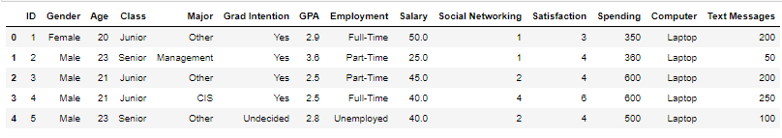
From this, we observe that dataset has 14 variables: ID, Gender, Age, Class, Major, Grad Intention, GPA, Employment, Salary, Social Networking, Satisfaction, Computer and Text Messages.
Gender, Class, Major, Grad Intention, Employment and Computer are categorical columns while GPA, Salary are float types and ID, Age, Social Networking, Satisfaction, Spending and Text Messages are all of integer type.
The dataset shows responses of 14 survey questions of 62 undergraduates from Clear Mountain State University.

Descriptive Statistic for the Dataset:
Now, we will try to understand the features of this data through short summaries regarding the measures and statistics.
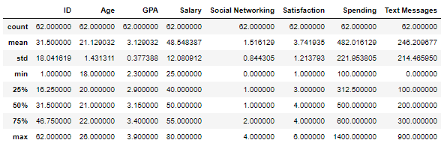
We can observe that, the age of students is between 18 to 26 years.
Also, the average salary is 48.548387

Checking for Null Values in the dataset

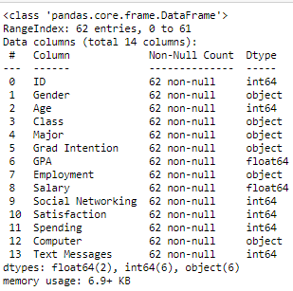
From the above results, it is evident that there are no null values in the dataset.
Also, the dataset has 62 instances and 14 attributes.

Q 2.1. For this data, construct the following contingency tables (Keep Gender as row variable)

2.1.1. Gender and Major
Here, rows depict the Gender and Columns depict the Major
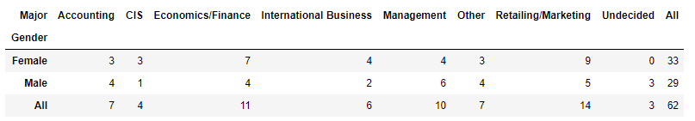

2.1.2. Gender and Grad Intention
Here, rows depict the Gender and Columns depict the Grad Intention
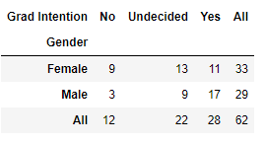
2.1.3. Gender and Employment
Here, rows depict the Gender and Columns depict the Employment
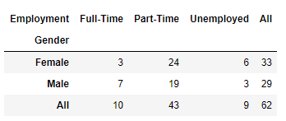
2.1.4. Gender and Computer
Here, rows depict the Gender and Columns depict the Computer attribute.
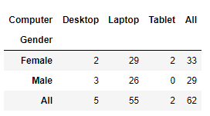

Q 2.2. Assume that the sample is representative of the population of CMSU. Based on the data, answer the following question:
2.2.1. What is the probability that a randomly selected CMSU student will be male?
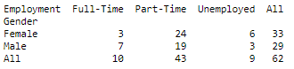
Using the above mentioned contingency table between gender and employment,
Total Students=62
Total No. of Males=29
Probability that a randomly selected student is a male= (Total No. of Males/ Total Students)*100
Answer: Probability that a randomly selected CMSU student is a male is 46.8%

2.2.2. What is the probability that a randomly selected CMSU student will be female?
Using the above mentioned contingency table between gender and employment,
Total Students=62
Total No. of Females=33
Probability that a randomly selected student is a female= (Total No. of females/ Total Students)*100
Answer: Probability that a randomly selected CMSU student is a female is 53.2%

Q 2.3. Assume that the sample is representative of the population of CMSU. Based on the data, answer the following question:

2.3.1. Find the conditional probability of different majors among the male students in CMSU.

Taking data from the above mentioned contingency table:

Total Male Students=29

Let, Total Males in a particular major=X

Conditional Probability of different majors among the male students in CMSU = (Total Males in a particular major/ Total Male Students)*100
=(X/ 29)*100

Total Males with Major in Accounting=4
Total Males with Major in CIS=1
Total Males with Major in Economics/Finance=4
Total Males with Major in International Business=2
Total Males with Major in Management=6

Total Males with Major in Other=4
Total Males with Major in Retailing/Marketing=5
Total Males with Major Undecided=3

This way, we calculated for every major.

Probability that a male student is from Accounting Major is 13.8%
Probability that a male student is from CIS Major is 3.5%
Probability that a male student is from Economics/Finance Major is 13.8%
Probability that a male student is from International Business Major is 6.9%
Probability that a male student is from Management Major is 20.7%
Probability that a male student is from Other Major is 13.8%
Probability that a male student is from Retailing/Marketing Major is 17.2%
Probability that a male student is from Undecided Major is 10.3%

2.3.2 Find the conditional probability of different majors among the female students of CMSU.
Taking data from the above mentioned contingency table:

Total Female Students=33

Let, Total Female in a particular major=Y

Conditional Probability of different majors among the Female students in CMSU = (Total Female in a particular major/ Total Female Students)*100
=(Y/ 33)*100

Total Female with Major in Accounting=3
Total Female with Major in CIS=3
Total Female with Major in Economics/Finance=7
Total Female with Major in International Business=4
Total Female with Major in Management=4
Total Female with Major in Other=3
Total Female with Major in Retailing/Marketing=9
Total Female with Major Undecided=0

This way, we calculated for every major.

Probability that a Female student is from Accounting Major is 9.1%
Probability that a Female student is from CIS Major is 9.1%
Probability that a Female student is from Economics/Finance Major is 21.2%
Probability that a Female student is from International Business Major is 12.1%
Probability that a Female student is from Management Major is 12.1%
Probability that a Female student is from Other Major is 9.1%
Probability that a Female student is from Retailing/Marketing Major is 27.3%
Probability that a Female student is from Undecided Major is 0.0%

Q 2.4. Assume that the sample is a representative of the population of CMSU. Based on the data, answer the following question:
2.4.1. Find the probability that a randomly chosen student is a male and intends to graduate.
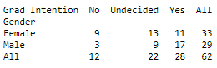
Total Students=62
Total Males who also intend to graduate (Yes) =17
Probability that a randomly chosen student is a male and intends to graduate = (Total Males who also intend to graduate / Total Students)*100
Answer: Probability that a randomly selected CMSU student is a male and intends to graduate is 27.4%

2.4.2 Find the probability that a randomly selected student is a female and does NOT have a laptop.
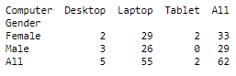
Total Students=62
Total female who does not have a laptop= (Female who have desktop + Female who have tablet) = 2+ 2= 4
Probability that a randomly selected student is a female and does NOT have a laptop = (Total female who does not have a laptop / Total Students)*100
Answer: Probability that a randomly selected CMSU student is a female and does NOT have a laptop is 6.5%

Q 2.5. Assume that the sample is representative of the population of CMSU. Based on the data, answer the following question:
2.5.1. Find the probability that a randomly chosen student is either a male or has full-time employment?
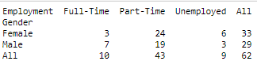
Total Students=62
Males who are Fulltime=7
Total no. of Males=29
All Fulltime Students=10
Probability (either a Male or a Fulltime) = Probability (Males) + Probability (Fulltime) - Probability (Males who are fulltime)
Probability that a randomly selected CMSU student is either a male or has full-time employment is 51.6%

2.5.2. Find the conditional probability that given a female student is randomly chosen, she is majoring in international business or management.
As calculated in Question 2.3.2
Probability that a Female student is from International Business Major = 12.1%
Probability that a Female student is from Management Major = 12.1%
Majoring in International Business and Management are both independent events.
Probability a random female student is majoring in international business or management= (Probability of females majoring in IB + Probability of females majoring in Management)
P_IB_or_Mgmt= Prob_Female_IB + Prob_Female_Mgmt
= (12.1% + 12.1%)
Probability that a randomly selected CMSU female student is majoring either in International Business or Management is 24.2%
Q 2.6. Construct a contingency table of Gender and Intent to Graduate at 2 levels (Yes/No). The Undecided students are not considered now and the table is a 2x2 table. Do you think the graduate intention and being female are independent events?
Below mentioned is the contingency table of Gender and Intent to Graduate at 2 levels (Yes/No)
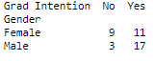
For checking, whether Graduate Intention and Being a female are dependent or independent events, we need to check two different probabilities.
If Probability that a random chosen student has an intent to graduate is equal to the probability that a randomly chosen female student has an intent to graduate, then they are independent events.
Upon calculating, we found out that,
Probability that a randomly selected CMSU student has an intent to graduate is 45.2%
Probability that a randomly selected female student has an intent to graduate is 17.7%
As we can see that, there is a huge difference between both the probabilities.
Therefore, both graduate intention and being female are independent events are dependent events.
Q 2.7. Note that there are four numerical (continuous) variables in the data set, GPA, Salary, Spending, and Text Messages.
Answer the following questions based on the data

2.7.1. If a student is chosen randomly, what is the probability that his/her GPA is less than 3?
We have used the count function on the dataset with condition that GPA< 3
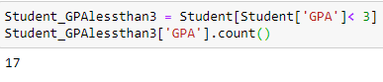
Total_Students_GPAlessthan3 = 17
Total_Students= 62
Prob_Students_GPAlessthan3= (Total students with GPA less than 3/Total_Students)*100
Probability that a randomly selected student has a GPA less than 3 is 27.4%
2.7.2. Find the conditional probability that a randomly selected male earns 50 or more. Find the conditional probability that a randomly selected female earns 50 or more.
We have grouped the dataset on Gender and then applied the condition of earning more than 50
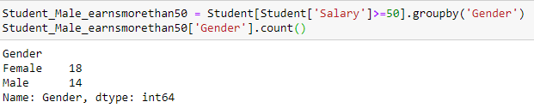
Males_earnsmorethan50 = 14
Females_earnsmorethan50=18
Total_Students= 62
Prob_Males_earnsmorethan50= (Males_earnsmorethan50 /Total_Students)*100
Similarly, we calculated for females.
Probability that a randomly selected student male earns more than 50 is 22.6%
Probability that a randomly selected student female earns more than 50 is 29.0%

Q 2.8.1 Note that there are four numerical (continuous) variables in the data set, GPA, Salary, Spending, and Text Messages. For each of them comment whether they follow a normal distribution. Write a note summarizing your conclusions.
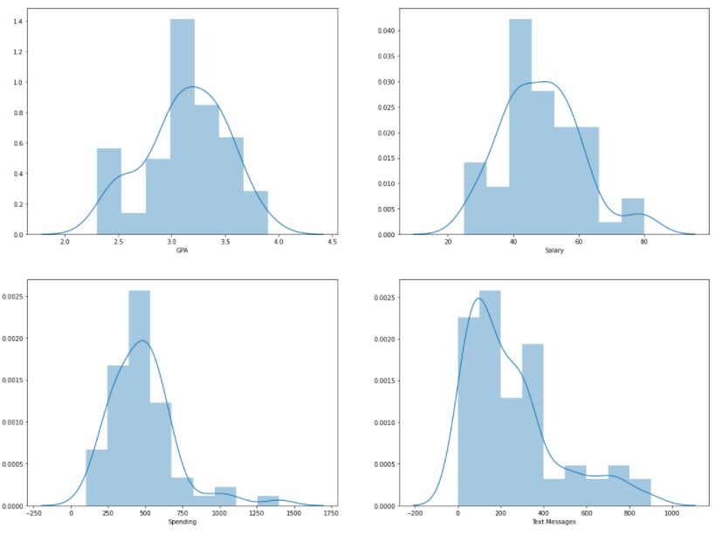
Plotting a distplot to see whether GPA, Salary, Spending and Text Messages follow normal distribution and are continuous.
Now, implying Empirical rule of normal distribution which states that 99.7% of data observed following a normal distribution lies within 3 standard deviations of the mean. Under this rule, 68% of the data falls within one standard deviation, 95% percent within two standard deviations, and 99.7% within three standard deviations from the mean.

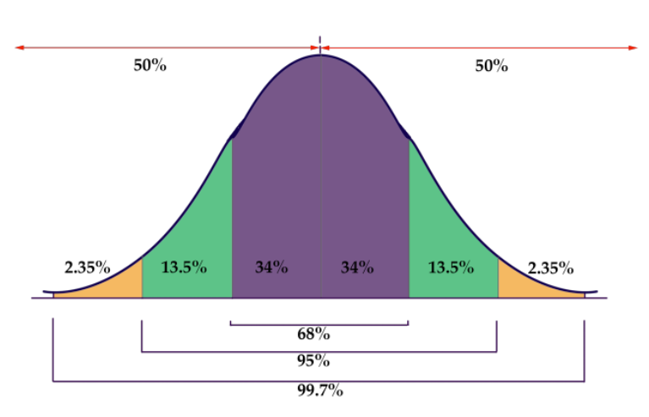
The empirical formula statistics for all four variables is shown below:
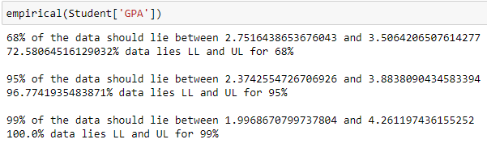
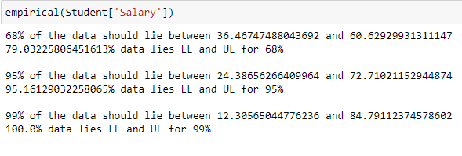
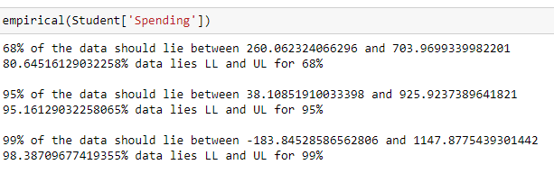
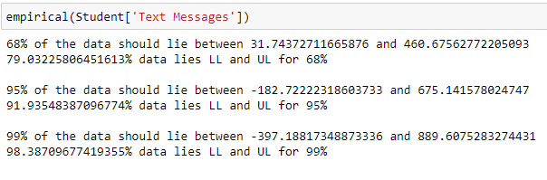
Also, performing Shapiro-Wilk Test
Shapiro Test-
The Shapiro-Wilk test is a way to tell if a random sample comes from a normal distribution. The test gives you a W value; small values indicate your sample is not normally distributed (you can reject the null hypothesis that your population is normally distributed if your values are under a certain threshold).
The formula for the W value is:
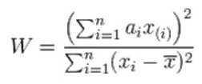
where:
xi are the ordered random sample values
ai are constants generated from the covariances, variances and means of the sample (size n) from a normally distributed sample.
Here, considering the null hypothesis that the variable follows normal-distribution.
Performing Shapiro’s Test on GPA
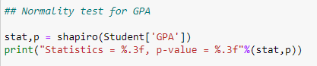
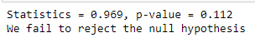
As the null-hypothesis is being accepted here, we can see that no significant departure from normality was found for GPA.
Performing Shapiro’s Test on Salary
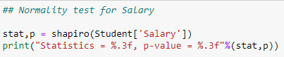
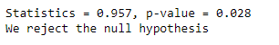
As the null-hypothesis is being rejected here, we can see that Salary does not follows a normal distribution.

Performing Shapiro’s Test on Spending
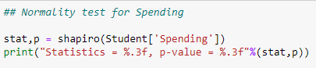
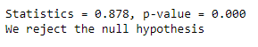
As the null-hypothesis is being rejected here, we can see that Spending does not follows a normal distribution.
Performing Shapiro’s Test on Text Messages
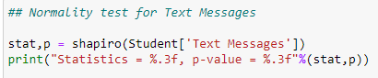
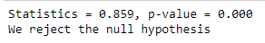
As the null-hypothesis is being rejected here, we can see that Text Messages does not follows a normal distribution.

Q 2.8.2 Write a note summarizing your conclusions.
Basis, the above analysis, we can summarize the statistics as below:

There are more number of females than the number of males in the University.
Majority of the Male students are majoring in either Management or Retail and Marketing.
Majority of the Female students are majoring in either Retail and Marketing or Economics and Finance.
Only 27.4% of males have an intention to graduate.
There are only 6.5% of females who does not have a laptop.
27.4 % of students have a GPA less than 3.
22.6% of male students earns more than 50
29.0% of female students earns more than 50

PROBLEM 3: (A & B shingles-1.csv)
An important quality characteristic used by the manufacturers of ABC asphalt shingles is the amount of moisture the shingles contain when they are packaged. Customers may feel that they have purchased a product lacking in quality if they find moisture and wet shingles inside the packaging. In some cases, excessive moisture can cause the granules attached to the shingles for texture and colouring purposes to fall off the shingles resulting in appearance problems. To monitor the amount of moisture present, the company conducts moisture tests. A shingle is weighed and then dried. The shingle is then reweighed, and based on the amount of moisture taken out of the product, the pounds of moisture per 100 square feet is calculated. The company would like to show that the mean moisture content is less than 0.35 pound per 100 square feet.
The file (A & B shingles.csv) includes 36 measurements (in pounds per 100 square feet) for A shingles and 31 for B shingles.
Please refer to the Jupyter File for the code working.
Exploratory Data Analysis (EDA):
We do the EDA of the data to discover patterns, summarize data and to observe the graphical representations.

Firstly, we will check on how the data looks like by showing the first five rows.
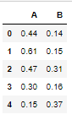
Here the dataset shows, moisture content in two types of Shingles A and B mentioned in different columns.
Descriptive Statistic for the Dataset:
Now, we will try to understand the features of this data through short summaries regarding the measures and statistics.
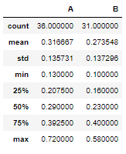
We can see that the mean moisture for Shingles A is 0.317 pounds and the mean moisture for Shingles B is 0.2735 pounds which is in the permissible limit.
Q 3.1 Do you think there is evidence that means moisture contents in both types of shingles are within the permissible limits? State your conclusions clearly showing all steps.
Yes, there is enough evidence to prove that means moisture contents in both types of shingles are within the permissible limits
Steps of testing the hypothesis:
Step 1 - Get the details
n=31
Alpha = 0.05
Step 2 - State the hypothesis
(Null Hypothesis) Ho= Mean moisture is less than or equal to 0.35 pounds
(Alternate Hypothesis) Ha= Mean moisture is greater than or equal to 0.35 pounds
We will be performing a one sample T-test on both the types of Shingles separately.
T-test is performed to compare the mean of the sample to a known value(which us 0.35 here).
One sample T-test on Shingles A
a) t_stat, p_value = stats.ttest_1samp(Shingles.A,0.35)
Print the statistics and p-value.
Print if you accept or reject the null hypothesis
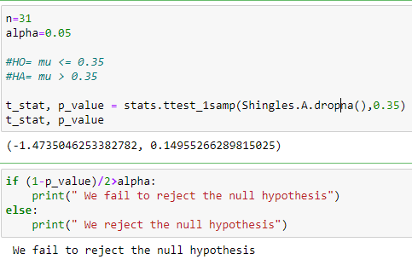
Here we fail to reject the Null hypothesis. Therefore, we can say that the mean moisture content in Shingles A is less than 0.35 pounds and is within the permissible limits.
One sample T-test on Shingles B
b) t_stat, p_value = stats.ttest_1samp(Shingles.B.dropna(),0.35) – ( Why drop na, because there are different observations.)
Print the statistics and p-value
Check the p-value (if Positive) , ensure you subtract from 1, that is , 1-p_value/2
Print if you accept or reject the null hypothesis
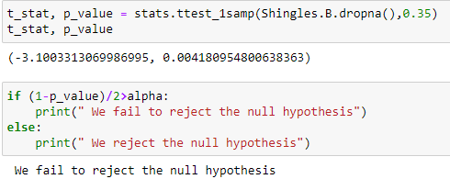
Here we fail to reject the Null hypothesis. Therefore, we can say that the mean moisture content in Shingles B is also less than 0.35 pounds and is within the permissible limits.
Q 3.2 Do you think that the population mean for shingles A and B are equal? Form the hypothesis and conduct the test of the hypothesis. What assumption do you need to check before the test for equality of means is performed?
Assumptions for T-Test
These should be checked before performing comparing the equality of the means.
1. The scale of measurement applied to the data follows a continuous or ordinal scale
2. The data is collected from a randomly selected portion of the total population
3. The data collected follows a normal distribution
4. Sample size should be large

Now, we need to check whether the population of mean of both the sample Shingles A & B are equal or not.
For that, we will be forming the hypothesis and then running tests on it.
The following steps need to be followed:
Step 1 - Mention the hypothesis
(Null Hypothesis) H0: Mu Shingles A = Mu Shingles B (Mean Moisture in both Shingles A and B are equal)
(Alternate Hypothesis) HA: Mu Shingles A ≠ Mu Shingles B (Mean Moisture in both Shingles A and B are different)
Step 2 - What is the alpha value?
Alpha=0.05 (at 95% confidence level)
Step 3- Mention what test will you perform.
We will be performing a two sample t-test to check whether the population mean of two samples is equal or not.
Step 4- Performing the Two sample test.
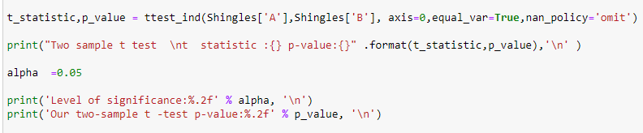
Step 5- Compare p_value with alpha.
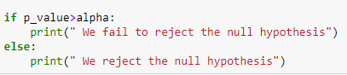
Output of two sample T-test
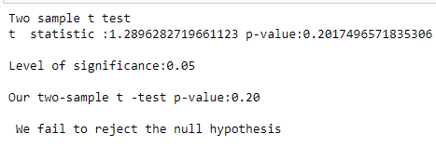
The test result says that, we fail to reject the null hypothesis.
Therefore, we can conclude that Mean moisture content of Shingles A is equal to Mean moisture content in Shingles B.

